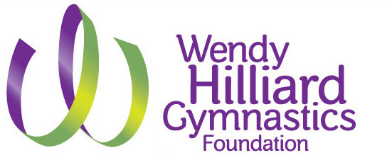

Harlem
Saturday Gymnastics Program Information
Fall Session
Oct 7 & 14 –
February 3, 2018

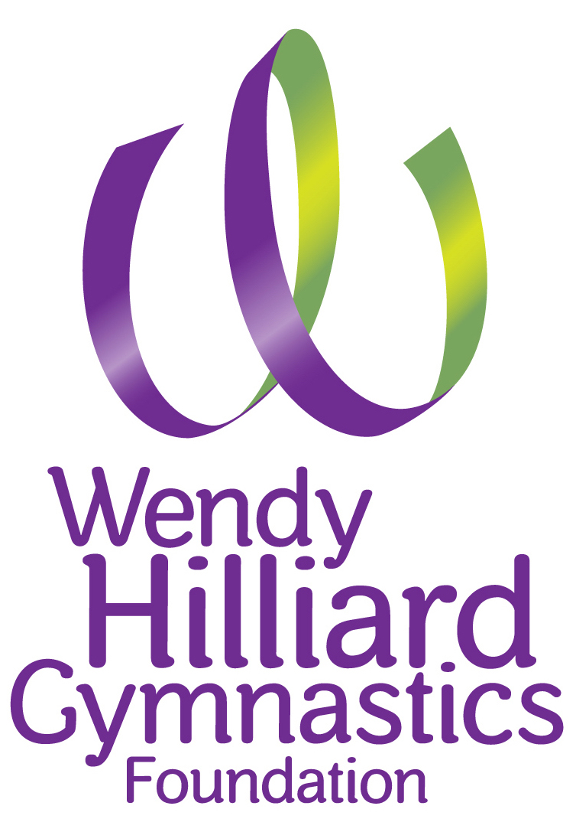

Board of Directors

Alpha Alexander
Vanessa Baylor
Herbert Berger
Val Calistro
Christopher Harrison
Wendy Hilliard
Hans Humes
Carol Kim
Brenda Levin
Dominick Minicucci Jr.
Kristina Oliver
Marion Phillips III
Janet Hill Talbert
Ginji Wang

550 West 155th Street
New York, NY 10032
212.316.0315
wendyhilliard.org

October 2018
Dear Parents,

Welcome to the WHGF Saturday Gymnastics Program. We are excited and look forward to teaching your children.
We have some changes to our WHGF Saturday Gymnastics Program.
- This season we will offer 2 sessions, a Fall Session from October 2017 -February 2018 and a Spring Session, February – June 2018. This will allow for easier payments and scheduling for you and my staff.
- There is also a Parent Portal for all students. This will improve communication and allow parents more flexibility.
- We have added 2 classes to our Saturday Community Gymnastics program. Ages 5-6, and 7-9 have two classes.
- Riverbank State Park classes begin on Oct 7, 2017 for ages 3-6
- HCZ Armory classes will begin on October 14, 2017 for ages 7-17.
This past May, Jocelyn Perusina joined us as the WHGF Office Manager. Most of you will be in contact with Jocelyn, as she is the point person for all registrations. Kirstie Darko has moved on this month and has a new job at Google. She has done a great job, especially managing the WHGF Summer Training Camp which has been a huge success.
I cannot say enough about the WHGF staff. They are talented, hard working and committed gymnastics instructors, coaches and administrative staff. We have our own way of doings things, but we never compromise on teaching great gymnastics and healthy workshops for our students.
The WHGF is a community program supported by partners, public officials, grants and other foundations that support our mission. I profoundly thank them for the opportunity to provide this service. Also, our Board of Directors who have committed their time, talent and treasure for the youth of the WHGF.
Of course, the WHGF Parents are key to the success of the WHGF and we need your input and support. We are expanding our WHGF Parents Club. It makes such a difference for our events and the best thing is working side by side with our WHGF Parents.
I am proud of is that the WHGF has been able to provide high quality yet affordable gymnastics programming. We offer scholarships to those families who need our support.

For me - I want all children that want to take gymnastics to participate in the sport I love so much.

All the best,

Wendy

WENDY HILLIARD GYMNASTICS FOUNDATION

Mission Statement

The mission of the WHGF is to provide opportunities to improve physical and emotional health to children of all ages in underserved communities.

ABOUT US:
The Wendy Hilliard Gymnastics Foundation (WHGF) is a non-profit organization dedicated to providing quality gymnastics training and activities for all youth in the Harlem community and its surrounding areas. Founded in New York City in 1996 by Hall of Fame rhythmic gymnast, WHGF was formed to provide free and low cost gymnastics for youth. WHGF is staffed by a team of trained and experienced coaches, who help provide opportunities for young people between the ages of 3-17 years old, to develop essential life skills such as hard work, discipline, team work and self-confidence. These life skills qualities are obtained by teaching our students the sports of gymnastics and its associated disciplines. Our students learn, perform and compete in gymnastics, which introduces them to these qualities. Additionally, aside from enhancing their athletic and social skills, WHGF places substantial emphasis on personal potential and growth through quality instruction and workshops in reading, personal health and nutrition.

WHGF Gymnastics Classes

Ages 3-4

Concentration will be motor skills, laterality, directionality, eye-hand coordination, and basic gymnastic skills by using size-appropriate equipment. Children will find beams, bars, and mats all designed to fit their smaller bodies and hands. This class is for 45 minutes.

Ages 5-17
The Saturday Gymnastics Program is an introduction to gymnastics and a beginner gymnastics program.
Students will begin to learn a higher level of structure in this class. Choreography based warm up to fine tune performing as a group. Development of gymnastics skills: handstands, back bends, cartwheels and drills for more advanced skills. Students will also learn rhythmic gymnastics and tumbling to become well-rounded gymnast. Students will also be given routines to perform on their own to increase muscle memory skills. This class is for one hour.
Intermediate Gymnastics

This class is for the more advanced gymnast. A child must be evaluated to enter this class. This class is for one-½ hours.

Special Needs Students

All students must be assessed - students may require parent/assistance during class. Staff will determine which time and class is best suited for each student. Motor skill development, tumbling and rhythmic gymnastics. The WHGF has had good success integrating children with physical and mental challenges into our classes. This has proven to be beneficial for all --the individual participants and all of the gymnastics students. Please contact the office for registration.

WHGF Saturday Community Gymnastics Schedule
*Subject to change as of October 13, 2017

Riverbank:
Ages 3-4: 4:00 - 4:45 PM
Ages 5-6: 4:45 - 5:45 PM
Ages 5-6: 5:45 - 6:45 PM

HCZ Harlem Armory:
Ages 10-17: 10 - 11:00 AM Intermediate: 11AM - 12:30 PM
Ages 7-9: 12:15 - 1:15 PM
Ages 7-9: 1:15 - 2:15 PM

Save the Date!

Harlem Gymnastics Invitational & Showtime in Harlem
February 23-25, 2018 – HCZ Armory

*WHGF partners with the Harlem Children’s Zone and Riverbank State Park for our gymnastics classes. They provide a safe, clean and wonderful environment for gymnastics. This is how the WHGF can provide high quality - yet affordable gymnastics programs. We work closely with our partners to have a consistent schedule, but at times we must change or cancel a class due to the changing schedules of our partners. The WHGF is a committed to the community and working together we have brought incredible gymnastics to Harlem. Schedules are subject to change based on the venues and agreements*

NO MAKE UP CLASSES
The WHGF Community Gymnastics Program does not offer make up classes. The WHGF will only add an extra class if a schedule class is cancelled due to unforeseen circumstances.

NO CLASSES ON FOLLOWING DATES:
October 28 (Riverbank Only) November 11, 2017 (Riverbank Only), November 25, 2017, December 9, 2017, December 23, 2017, December 30, 2017, March 3, 2018 (Riverbank), March 24, 2018 (Armory), May 19, 2018 (Armory), May 26, 2018.

Class/Age | Location | Fall Session Tuition
Ages 3-6 | Riverbank State Park | $360 per session
Ages 7-17 | Harlem HCZ Armory | $360 per session
Intermediate Ages 7-17 | Harlem HCZ Armory | $490 per session

Register at www.wendyhilliard.org
Please contact (212)-316-0315 or admin@wendyhilliardfoundation.org
for Special Needs & Intermediate Registration

ANNUAL REGISTRATION FEE $55:
The registration fee is due at the time of enrollment. The registration fee is $55 for each student. The registration fee is non-refundable. Classes can only be reserved by paying the registration fee AND the first payment of classes

PAYMENT PLAN
A payment plan is available. Payments can be divided into 3 payments. 1st payment due at registration, the next payment of $120 will be due after one month, and the final $120 will be due the following month.
This plan is based on the overall tuition - NOT the amount of gymnastics classes per month.

Beginner class first payment is $175 (Non –Refundable Registration fee included).

Intermediate class first payment is $200 (Non –Refundable Registration fee included).

Adjustments will be made for sibling discounts, and scholarships if qualified.

DISCOUNTS
15% for each sibling after first child
Only one discount is offered per student but families may qualify for multiple discounts.

REFUNDS/DROP POLICY:
Refund requests must be submitted in writing or by email to admin@wendyhilliardfoundation.org
Refund approvals will be on a case by case basis.

Those who do not pay on time or fall behind on payments may be dropped from the program and/or will not be allowed to register for future sessions.

OK - I am ready to go! How much will it cost me to register?

This pricing includes, one-time registration fee, and gymnastics tuition

These are the Registration Cost Per Session before October 7 & 14th 2017:
Fees will be prorated for late registration

Paying in full beginner class - $415
(one time registration fee included)

Payment plan beginner class - $175 at the time of registration
(First tuition payment, and annual registration fee included)
(2 payments of $120 thereafter)

Payment plan siblings discount beginner class - $157 at the time of registration
(15% tuition discount applied- first tuition payment, and annual registration fee included)
($102 installment payments thereafter)
If your child has not been invited to participate in the intermediate program you should sign up for the beginner class.

Paying in full intermediate class - $490
(Annual registration fee included)

Payment plan intermediate class - $200 at the time of registration
(First tuition payment, and one-time registration fee included)
(2 payments of $145 thereafter)

Monthly payment plan siblings discount intermediate class - $178.25 at the time of registration
(15% tuition discount applied- first month’s tuition, and one-time registration fee included)
(2 payments of $123.25 thereafter)

SCHOLARSHIPS: Wendy Hilliard Gymnastics Foundation offers scholarships to families who may need additional assistance with their tuition. The application requirements are listed on our website and attached to this packet.

SCHOLARSHIP REQUIREMENTS

All scholarships applications and required documents must be turned in by Sept 1st, 2017 in one single file/email, NO EXCEPTIONS! Please also note that there are limited numbers of scholarships available, receiving a scholarship is not guaranteed!

For scholarship consideration, please submit the following to our office:

• A typed letter requesting consideration and explanation of your circumstances.

And at least 2 of the following for financial verification:

• A copy of your current 1040 for proof of income
• A current pay statement or check stub
• A copy of your SSI Benefit Letter (Supplemental Security Income)
• A copy of recent unemployment statement
• A copy of child support statement
• NYC Housing Authority Voucher Letter (Section 8 Letter)
• HRA Award Letter or Budget Letter

Scholarship determination is based on NYC-HRA Income Eligibility Guidelines.

DO NOT SEND ORGINAL FINANCIAL INFORMATION. Send information to:
Wendy Hilliard Gymnastics Foundation
550 West 155 Street
New York, NY 10032
Admin@wendyhilliardfoundation.org

If you have any further questions, please contact us via email Admin@wendyhilliardfoundation.org
or telephone 212-316-0315. You will receive a response to your request as soon as possible.
Thank you for your interest.

Common Questions
Why can’t the parents be in the gym during the class? We have the parents wait outside so the children do not become distracted. One of the goals of our program is to teach the students to pay close attention to their gymnastics instructors and to learn the process of sports discipline and how to follow directions. For some of the younger students, we allow the parents in the gym to help make the transition to class participation. This process usually takes 1-3 classes. No parent should ever enter the gym without permission from the WHGF Staff. If you need to speak with your child or have a question make sure to have a WHGF Staff accompany you. The same applies if you have questions or concerns. Due to the tight turn around of the classes and children moving from one class to the next it is difficult for the gymnastics staff to answer questions on site right away. Please be patient and wait for class to get underway and then approach a WHGF Staff person or call or email the office during the week.
Why must the student wear the same uniform? This is a choice of the WHGF and many other programs- karate and dance for example. We recommend bare feet because it is the best way to prevent slipping. White socks are required for the HCZ Armory classes. No oversize clothes are allowed for safety reasons. Other safety issues include no hoop or dangling earrings and other jewelry. Small post earrings are allowed. Hair must be secured away from the face.
What will the children learn in class? Depending on the age group the skills that are taught in this program are basic gymnastics skills. Gymnastics has several disciplines and the WHGF classes focus learning gymnastics fundamentals, physical conditioning and learning routines to music. Tumbling is the foundation for all gymnastics disciplines. Even before learning to tumble students must learn how to warm up their bodies and develop overall body strength and flexibility. We start with a warm up to music that helps the students learn the moves while the music and repetition allows them to progress faster. If students are late to class they will have to do exercises to warm up their bodies up before they can join their groups. Often times they are push up or jumping jacks…. We test all the students ages 6 and up at the beginning of the session. After a few sessions the students are divided into groups according to ability. Initially they are separated by age and/or height. After the warm up the students rotate to different events spending about 10 – 15 minutes per event. The students may not rotate to each event each week but throughout the course of the session they will work on all of the different groups. Besides tumbling most students also rotate to a rhythmic gymnastics event. Rhythmic gymnastics uses hand apparatus i.e. hoops, ribbons and balls. This helps develop important hand and eye coordination and also helps develop good alignment. One session may concentrate on dance movements. All gymnasts have to learn a good amount of dance movement to enhance their gymnastics. All of the sessions develop coordination.
How are the WHGF gymnastics instructor selected? The selection of good gymnastics instructors is the most important aspect of the WHGF programs. All instructors have to have a background or training in gymnastics and also have to follow specific safety rules. Wendy Hilliard has worked with most of the instructors in her program for several years. Some were former students and some came from other gymnastics programs. Most instructors were former competitive athletes. All instructors go through a trial period before they are hired by the WHGF to determine if they have the necessary teaching skills for our program. We also have some assistant coaches who work alongside the WHGF instructors.
Why must the students participate in the reading and nutrition workshops? The WHGF reading and nutrition workshops that coincide with the gymnastics program developed out of requirements from WHGF funders which allow us to provide high quality programs for low cost and/or free of charge. Over the years these workshops have enhanced the WHGF programming and given the students that come through our programs a well-rounded experience and also the ability to use the discipline learned through gymnastics and apply it to other areas of their life. In addition, these workshops allow the WHGF staff to learn more about the students and their personalities and also give the parents good information about nutrition for budding athletes.
Why is so much time spent on the gala performance? The WHGF Galas that are generally held at the end of the school year. Galas give the students a chance to showcase their abilities and also to be exposed to champion and professional gymnasts. In addition, preparing for the gala challenges the students learn routines and gymnastics elements. We also have “Showtime in Harlem” in February that is held in conjunction with our Harlem Gymnastics Invitational. All of the WHGF students perform and get the opportunity to watch great gymnasts compete from around the country.
What if my child wants to take an advanced class or be on the competitive team? The best way is for a WHGF instructor to recommend your child for a more advanced class. The WHGF instructors select students based on interest, ability, attitude and following instructions. This is by invitation/audition only. The WHGF staff will test students by request.
What if there may be a storm? Please either call the WHGF office 212 316-0315 or check the website WendyHilliard.org on the day of classes.
If my child misses a class or class is cancelled are there make up classes? No, unfortunately we have to set our schedule with Riverbank State Park and Harlem Children’s Zone in advance and there are not a lot of options for make-up classes. Occasionally we will reschedule a class if possible.
If you have any other questions emails is best admin@wendyhillardfoundation.org or call the WHGF office Monday- Friday 10:30am -5:30pm.

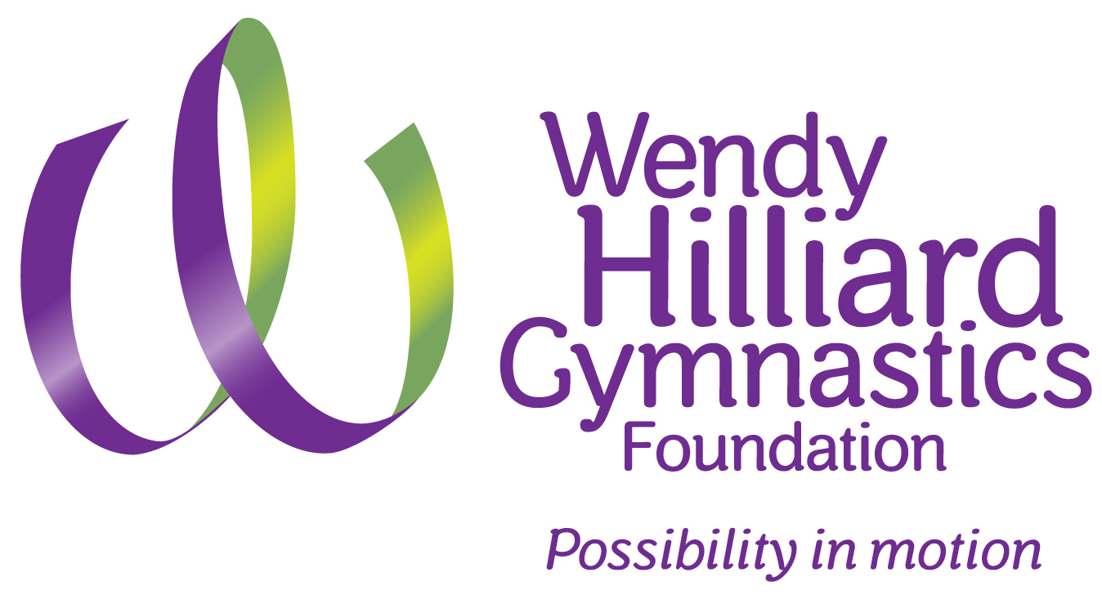

SATURDAY GYMNASTICS PROGRAM RULES & REGULATIONS
We have compiled this guide to familiarize you with the procedures of our program. Please review the rules with your child and keep this guide for reference. If you have any questions regarding any aspect of this program, please email or call us.

- ALL STUDENTS MUST SIGN IN AND CHECK ATTENDANCE AT WENDY HILLIARD GYMNASTICS FOUNDATION DESK.
- ARRIVE ON TIME FOR YOUR CLASS SESSION. STUDENTS MAY NOT BE PERMITTED TO ENTER CLASS LATE THIS IS AT THE DISCRETION OF THE GYMNASTICS INSTRUCTORS. IN ADDITION, PARENTS MUST BE ON TIME TO PICK UP STUDENTS.
- PARENTS MUST WAIT FOR STUDENTS OUTSIDE THE GYM. PARENTS ARE ALLOWED TO OBSERVE THE CLASS IN THE GYM EXCEPT ON PARENTS DAY.
- NO GUM, CANDY, FOOD OR BEVERAGES INSIDE GYM.
- WORKSHOP PARTICIPATION IS REQUIRED OF ALL STUDENTS.
- NO RUNNING IN GYM WITHOUT PERMISSION.
- STUDENTS MUST NEVER ATTEMPT A NEW SKILL OR USE APPARATUS WITHOUT PERMISSION.
- PERMISSION MUST BE RECEIVED FROM THE INSTRUCTOR TO USE THE REST ROOM OR FOR WATER BREAKS DURING CLASS.
- STUDENTS OR PARENTS BEHAVING IN A DISRUPTIVE MANNER WILL BE DISMISSED FROM CLASS IMMEDIATELY. CONTINUING MISCONDUCT WILL RESULT IN DISMISSAL FROM THE PROGRAM.
- WHAT TO WEAR: WHGF leotard or gymnastics compression shirt. Black spandex shorts or black leggings (without feet) can be worn for each class. White socks only (bare feet preferred for ages 3-6) No ballet shoes, tights with feet, oversized T-shirts, sneakers or sandals. No jewelry, except small post earrings. Long OR loose hair must be secured away from the face in ponytail or bun--No barrettes or tie balls, especially at the top of the head.

Directions to Riverbank
679 Riverside Drive, New York, NY 10031

Transportation
1 Train to 145th St and Broadway
M4 Bus to Broadway and 145th street
M11 Bus to Riverside drive and 144th st

Directions to the Armory Gym
40 west 142nd street between Lenox Ave and 5th Ave

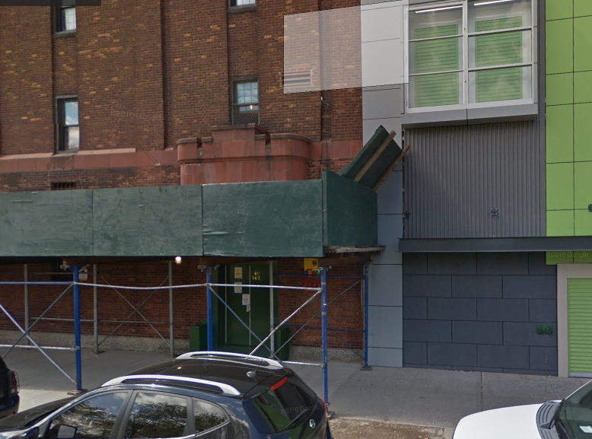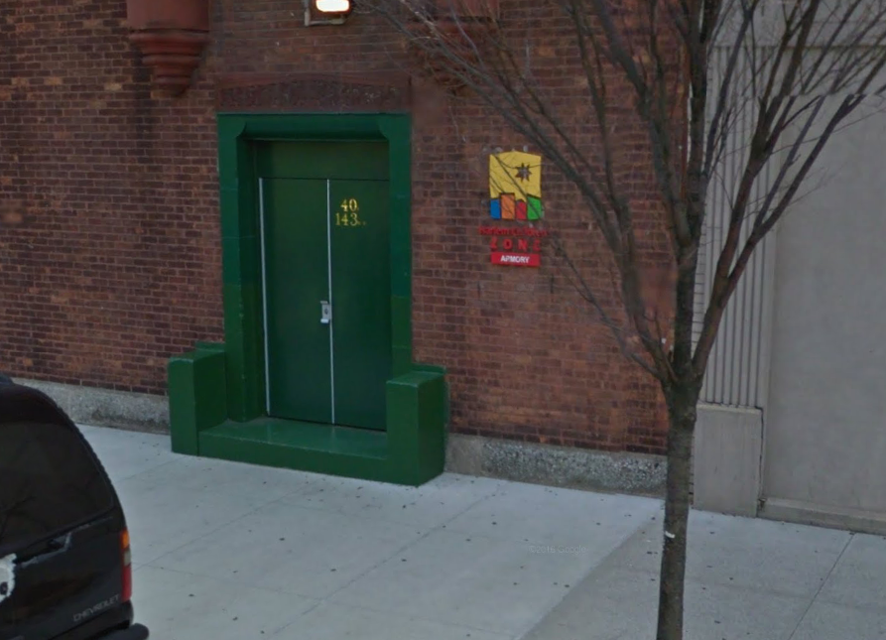
Transportation:
M7 bus to 142nd street and Lenox Ave
M102 bus to 142nd Street and Lenox
3 train to 145 Street
(Must be in the first 5 cars of the train)

Wendy Hilliard Gymnastics Foundation Office
550 West 155th Street Between Broadway and Amsterdam Avenue
(Enter up the steps on 155 Street located inside the Church of the Intersession next to the cemetery)

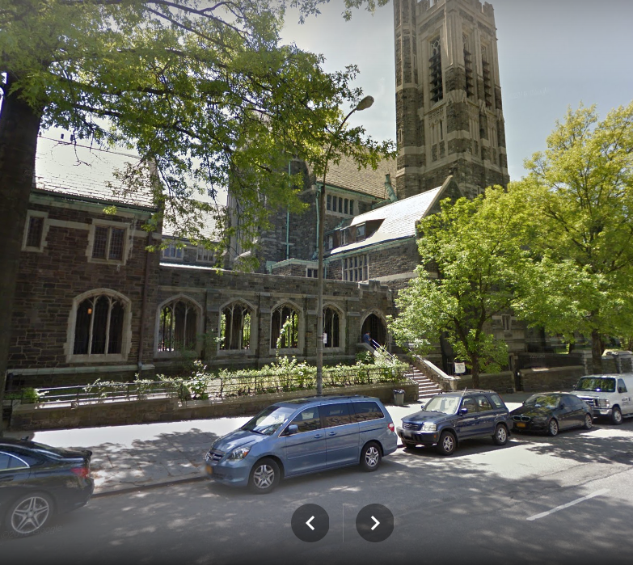

Transportation:

1 Train to 157th street and Broadway
C Train to 155th street and St. Nicholas
Bx6 to 155th street and Broadway
M3 to 155th street and Amsterdam

Contact us!

WHGF Main Office:
Hours of Operations: Mon-Fri 10:30am - 5:30pm
Address: 550 West 155 Street NYC 10032 (Between Broadway & Amsterdam)
Phone Number: 212-316-0315
Contact Purposes: For information on registering your child into the Wendy Hilliard Gymnastics Foundation Programs
Email: admin@wendyhilliardfoundation.org

WHGF Program Phone: (Saturdays 10am-7:30pm)
Phone: 646-647-9650
Contact Purposes: If your child is already enrolled into the gymnastics program, this number is for purposes of contacting us to inform changes in pick up times, people coming to pick up your child, and attendance of your child.
Email – Samantha@wendyhilliardfoundation.org

Harlem Children Zone Armory
Address: 40 West 143 Street NYC, 10037 (Between Lenox & 5th Ave)
Front Desk Phone: 212-281-5431

Riverbank State Park
Address: 679 Riverside Drive, New York, NY 10031
Front Desk Phone: 212-694-3600

